***Davis Data Science Club***

*Spring 2023*

*Sign Language Detection*

**TRAINING MODEL**

During Training the Model

Ran into a version error:

Updated protobuf by running this: pip install protobuf==3.20 ; this to command line

My workspace:

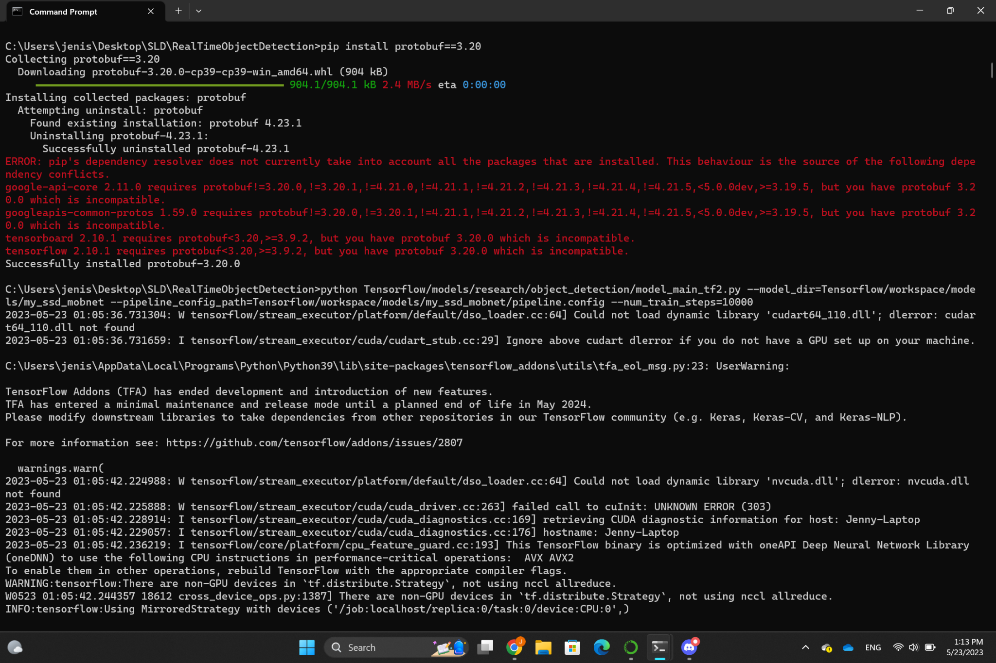

**!!TRAINING MODEL TAKES A LOT OF TIME!!**

An Overview of loss metrics in Time/step intervals

